AI StudyBuddy
Solution Architecture
Project Design Phase

Project | AI StudyBuddy
Project ID | SWTID-2026-7764
Source | Current source folders: backend/ and client/
Document status | Project-specific draft based on current backend/client source evidence
Prepared | 28 September 2026

Evidence baseline: current source files inspected from the backend/ and client/ folders. node_modules were not required. Claims not visible in source are labelled as implemented, partially implemented, proposed, unverified, or requiring verification.

Document Contents
- Architecture Summary
- Layer Mapping
- Architecture Decisions and Risks

Architecture Summary
The system follows a client–API–data/AI architecture. The frontend is a Vite-built React/TypeScript application. The backend is an Express application with route modules, JWT middleware, controllers, Mongoose models, a MongoDB connection, temporary file storage, and a Gemini utility.
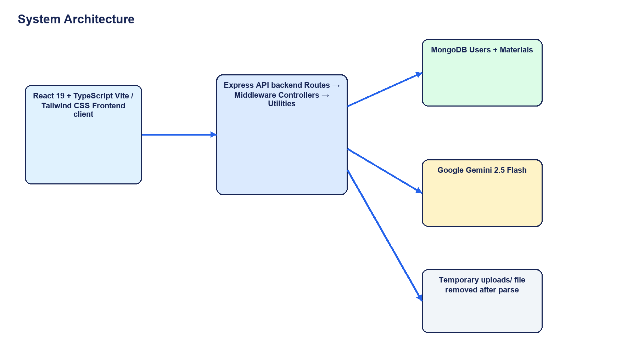
High-level component architecture based on the backend/ and client/ source folders.

Layer Mapping
Layer | Implementation | Responsibilities
Presentation | React components, Tailwind CSS, Framer Motion | Landing, auth, dashboard, materials, quiz, planner, notes, analytics
Client state | AuthContext and component state | Session hydration, view selection, UI interaction
API transport | src/services/api.ts | REST requests and Bearer token headers
HTTP/API | Express routes and index.js | Routing, JSON parsing, CORS, errors, health check
Security | protect and adminOnly middleware | JWT verification and role authorization
Application logic | Controllers | Auth, material processing, AI generation, admin operations
Data/AI utilities | Mongoose models, db.js, tokens.js, gemini.js | Persistence, token creation, MongoDB and Gemini integration

Architecture Decisions and Risks
- Generated summary, flashcards, quiz, and study plan are embedded in Material documents for simple retrieval.
- Uploaded files are temporary and deleted after text extraction; raw extracted content remains in MongoDB.
- The README describes HTTP-only cookie JWT storage, but the implementation returns JWTs in JSON and the frontend stores the access token in localStorage; the README description is outdated.
- The registration endpoint accepts role from the request body and the User model permits admin, so public users may be able to register as admins; role-based access is not fully secure.
- AuthContext and registration UI can create a local demo session when API calls fail; a dashboard opening is not proof of backend authentication.
- No Docker, CI/CD workflow, reverse-proxy configuration, or process manager configuration was evidenced.
- The requested AdminPanel component was not found in the selected current client source and remains a verification item.
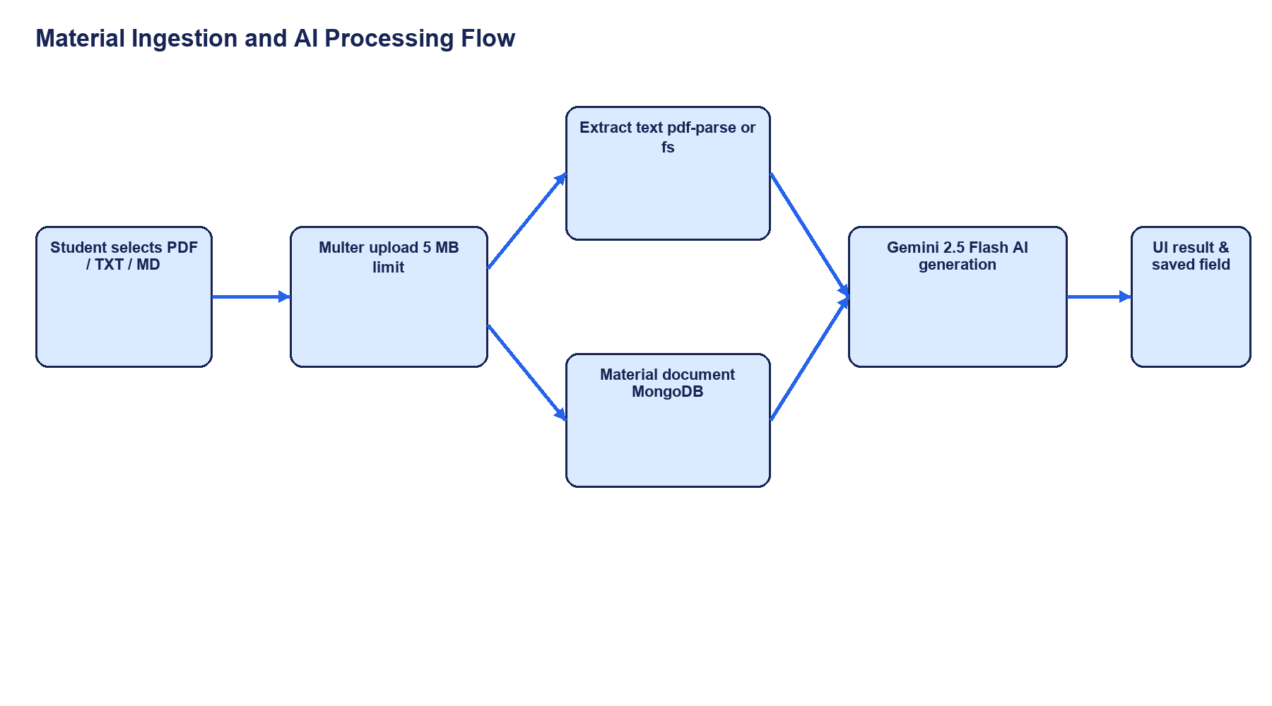
Material ingestion and AI processing data flow.

